Are you part of the 20/20 Team?
The 20/20 Team is a 10-year personal commitment in the amount of $100, $250 or $500 per year. It is not a Recognition gift. You may donate by check, credit card, PayPal, or by direct bill pay through your bank or credit union. You may also choose $8.50 per month instead of a one-time $100 gift; $21.00 per month instead of a one-time $250 gift; $42 per month instead of a one-time $500 gift. You may change the dollar amount from year to year.

It is a personal gift to the Lone Star Lions Eye Bank to help us meet our mission statement: “Lone Star Lions Eye Bank, Inc. is a Texas 501(c) 3 non-profit dedicated to the preservation of sight through the collection, processing, and distribution of human ocular tissue, progress in medicine through the support of research, and the sponsorship of educational programs for the medical community and general public.”
Donations can be made by check, cash, credit card, or for some of us are that MAGIC AGE of RMD (Required Minimum Distribution – it was 70-1/2, and is now 72) and QCD (Qualified Charitable Distribution). This can be a good way to be a part of the 20/20 Team. This 20/20 Team is not just for Lions. Anyone can be a donor to the Lone Star Lions Eye Bank 20/20 Visionary Club.
We accept donations by check, cash, credit card or you can go directly to the www.lsleb.org website and click on the “Support the LSLB CONTRIBUTE NOW” button at the top right of the webpage, and then click on the 20/20 Visionary Club $amount. Then complete to use PayPal, debit or credit card or you may complete the form below and send to the Lone Star Lions Eye Bank with your donation.

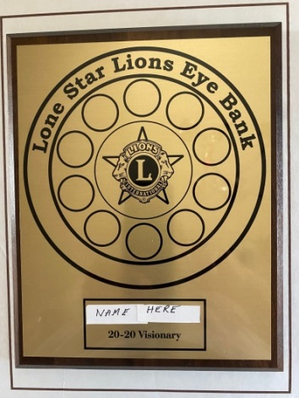

With your order of the 20/20 Plaque you also get a 20/20 Patch.

20/20 Visionary Donation: $100 ___ $250 ___ $500 ___

Name ____________________________________________________________________
Address _______________________________________ City _______________________
State ____ ZipCode ___________ Phone # ______________________________________
Email ____________________________________________________________________
LONE STAR LIONS EYE BANK, PO Box 347, Manor TX 78653 www.lsleb.org

